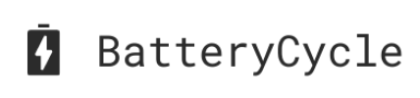

Dashboard requirement document

June 23, 2023

Battery Cycle

Table of Contents

Dashboard layout: 2

Sections: 3

Summary: 3

Age and Mileage: 5

EV Battery Health: 7

Forecast: 9

EV Battery Parc: 11

Data Source: 13

Dashboard Access: 13

Data Dictionary: 13

# Dashboard layout:

The dashboard will be divided into 5 different sections:

* Summary
* Parc Composition
* Age and Mileage
* EV Battery Health
* Forecast

Each section will have its own set of graphs and visualizations to relay the necessary analysis. Moreover, every section should have the Battery cycle logo visible when opened.

# Sections:

## Summary:

The summary section will have the following visualizations in it:

* 1. Predicted Number of EV’s in the Parc by Make and Year of Construction

Type of visualization: Multiple Line Chart

Description: Each line represents a different year from the forecasted data, whereas the X-axis represents different makes, and the Y-axis is representing the number of EV’s.

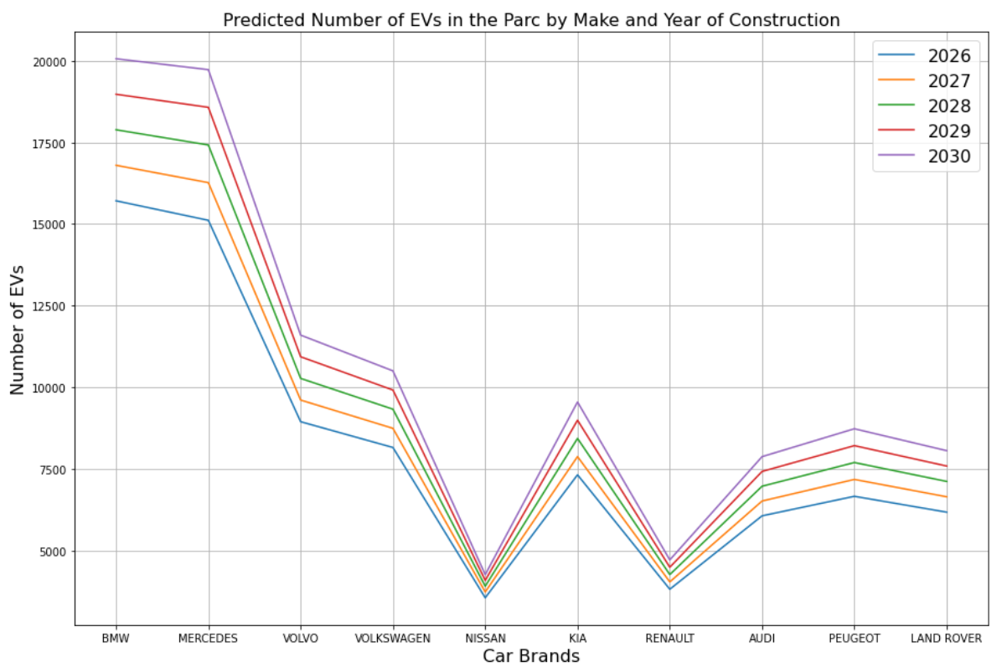

GitHub folder link: <https://github.com/varunraaju/Battery_Cycle_Plots/tree/a3ccf2c92e5eddc0972bd76c2c28c0eec426fb29/1_1>

* 1. Distribution of EVs in the Parc by Geographic Location

Type of visualization: Map Chart

Description: Shows the number of EV’s geographically by using hotspots where the number of EVs is concentrated.

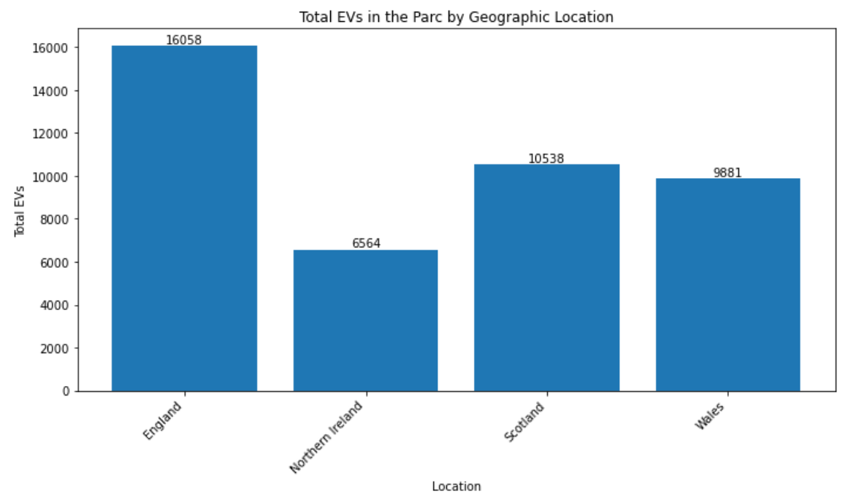

GitHub folder link: <https://github.com/varunraaju/Battery_Cycle_Plots/tree/39b1038d92a0ed0829b8eba63e964c3ad3097c89/1_2>

* 1. Top 10 Makes of EVs in the Parc

Type of visualization: Pie Chart

Description: This graph shows the top ten makers of EVs in the pie chart. The graph uses the share percentage of EVs across manufacturers instead of the number of EVs.

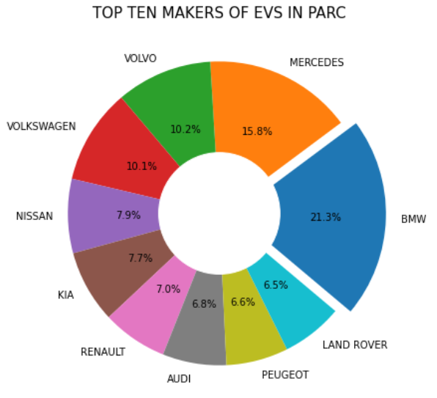

GitHub folder link: <https://github.com/varunraaju/Battery_Cycle_Plots/tree/a3ccf2c92e5eddc0972bd76c2c28c0eec426fb29/1_3>

* 1. EV Battery raw materials

Type of visualization: Clustered Bar chart

Description: This clustered bar chart has tons of material used on the Y-axis and the X-axis has the different materials used in battery manufacturing. The different bars in the clusters represent the last 3 years in the data.

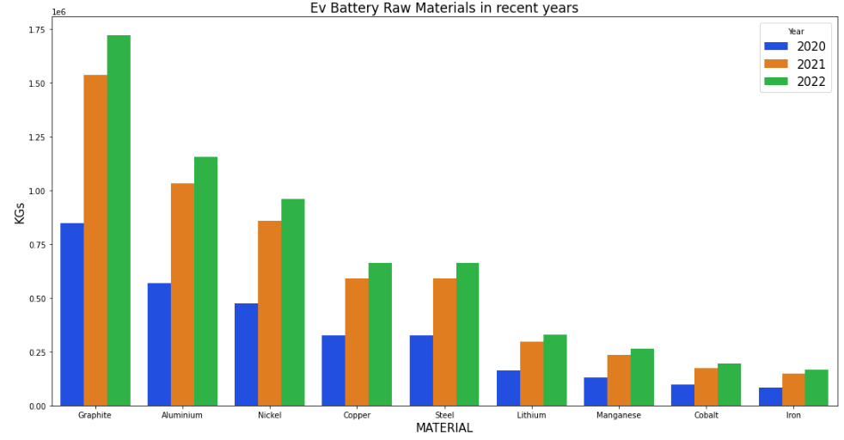

GitHub folder link: <https://github.com/varunraaju/Battery_Cycle_Plots/tree/a3ccf2c92e5eddc0972bd76c2c28c0eec426fb29/1_4>

* 1. Bar chart of the number of EVs by year of construction

Type of visualization: horizontal stacked bar chart

Description: This chart has the different years of manufacturing on the y-axis and the number of EVs on the X-axis. The different stacks on each bar represent the top 6 makers of EVs.

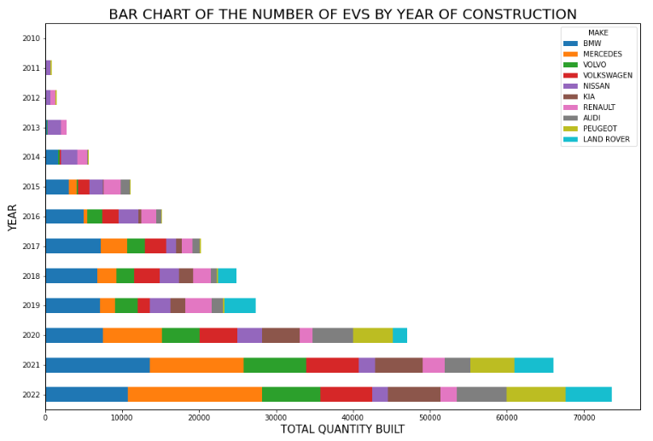

GitHub folder link: <https://github.com/varunraaju/Battery_Cycle_Plots/tree/a3ccf2c92e5eddc0972bd76c2c28c0eec426fb29/1_5>

## Age and Mileage:

The Age and Mileage section will have the following visualizations in it:

* 1. Number of EVs by Year of Construction and Mileage Category (UK)

Type of visualization: Area chart

Description: The y-axis represents the number of EVs, and X-axis represents the different years of construction. The area under the chart is divided based on mileage. The mileage will be divided into different ranges of 100 each (for e.g., <100, 100-200, 200-300, etc.)

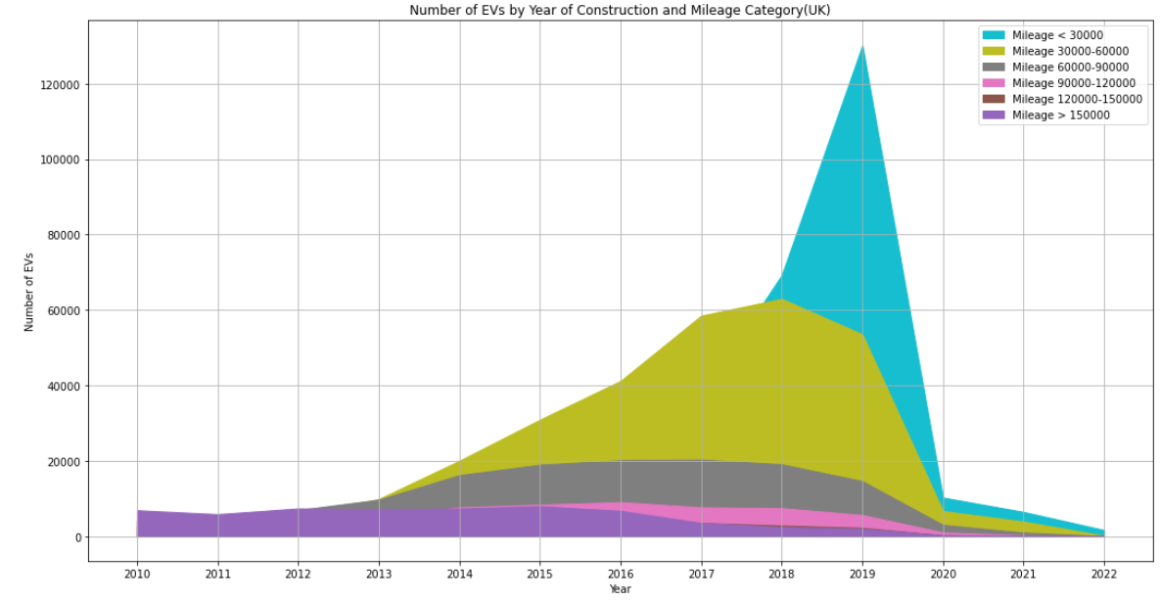

GitHub folder link: <https://github.com/varunraaju/Battery_Cycle_Plots/tree/a3ccf2c92e5eddc0972bd76c2c28c0eec426fb29/2_1>

* 1. Heatmap of the average age and mileage by EV model

Type of visualizations: Heatmap

Description: The Y-axis represents the age of the EVs, and X-axis represents the EV models. The values being used to colour the heatmap number of EVs having by mileage.

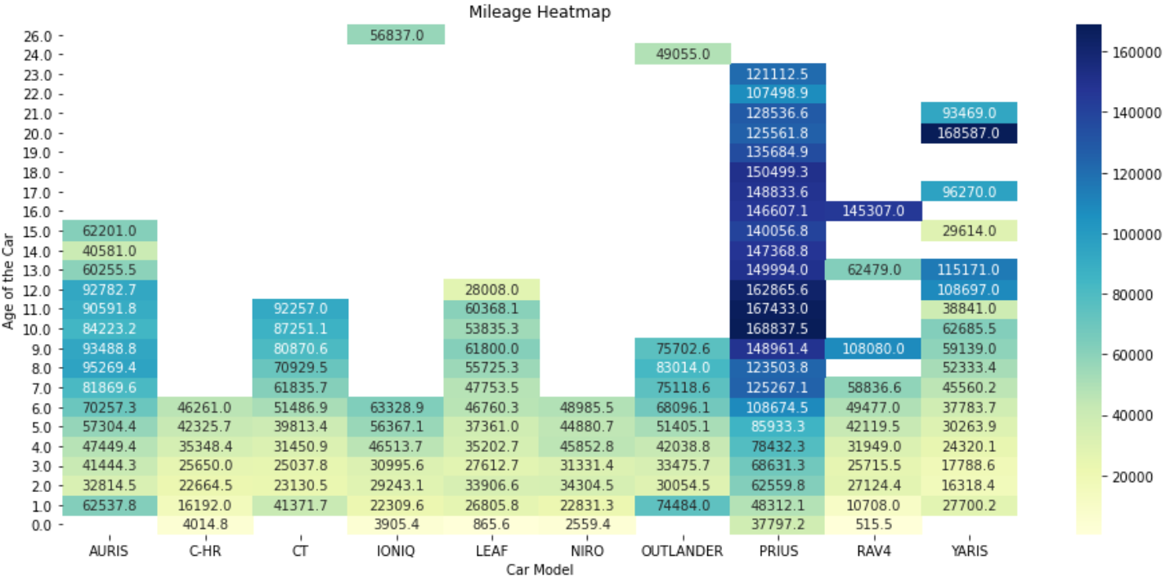

GitHub folder link: <https://github.com/varunraaju/Battery_Cycle_Plots/tree/a3ccf2c92e5eddc0972bd76c2c28c0eec426fb29/2_2>

* 1. Mileage Distribution by EV Models

Type of visualization: Violin plot

Description: The x-axis represents the EV models, and the y-axis represents the mileage on the EV vehicles. The area inside the violin is populated by the number of EVs.

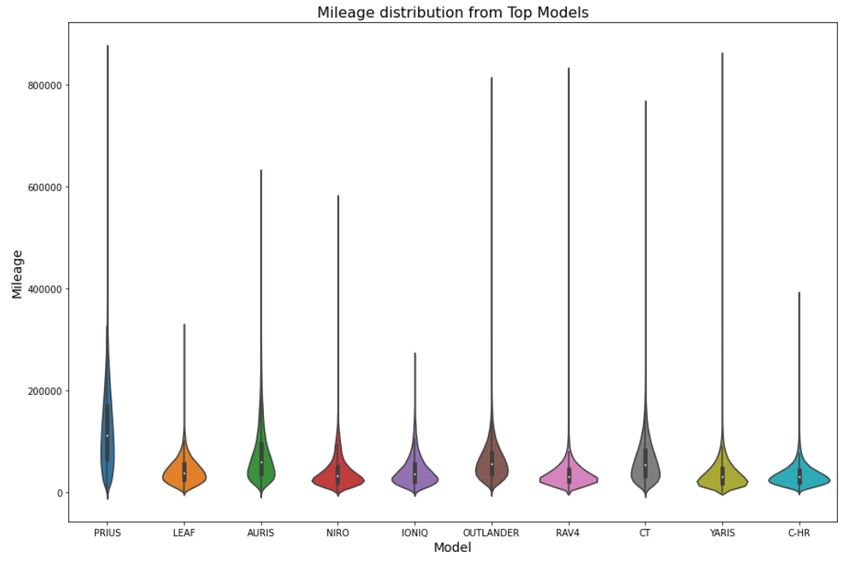

GitHub folder link: <https://github.com/varunraaju/Battery_Cycle_Plots/tree/a3ccf2c92e5eddc0972bd76c2c28c0eec426fb29/2_3>

* 1. Mileage of Top EV Models

Type of visualization: Bar graph

Description: The x-axis represents the EV models, and the y-axis represents the mileage on the EV vehicles.

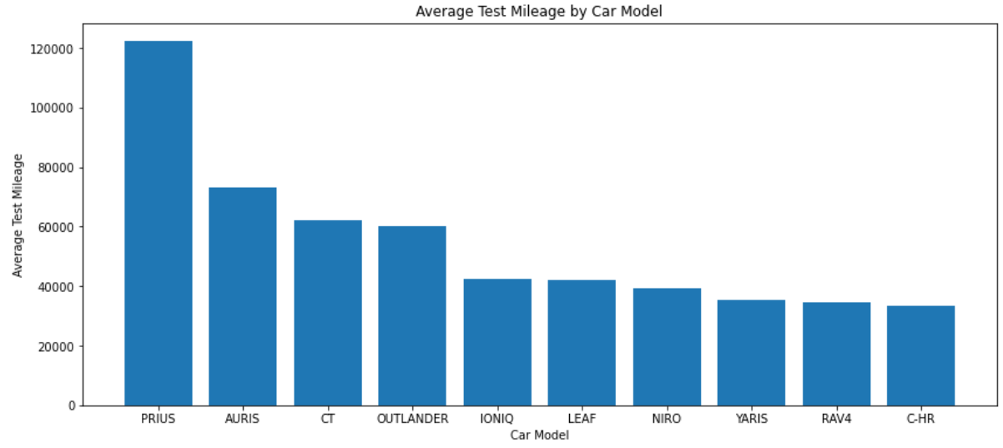

GitHub Folder link: <https://github.com/varunraaju/Battery_Cycle_Plots/tree/a3ccf2c92e5eddc0972bd76c2c28c0eec426fb29/2_4>

## EV Battery Health:

The EV Battery Health section will have the following visualizations in it:

* 1. Predicted Number of EVs by Year of Construction and Battery Health

Type of visualizations: Vertical stacked bar graph

Description: The X-axis represents the forecasted years from the forecasted data and Y-axis represents the number of EV’s. The different stacks represent the state of health of the battery.

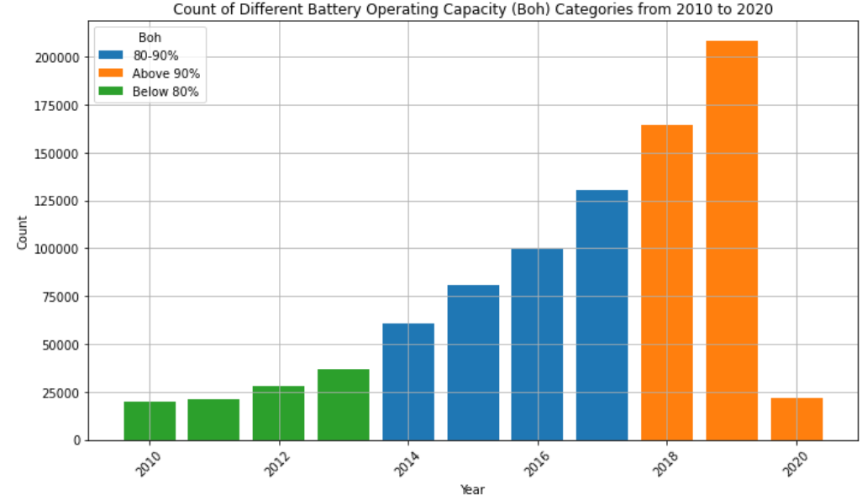

GitHub folder link: <https://github.com/varunraaju/Battery_Cycle_Plots/tree/608061ded6ebae0bb15f46ad1d8178f06cf7b97f/3_1>

* 1. Bar chart of the number of EVs by year of construction

Type of visualizations: Horizontal stacked bar graph

Description: The Y-axis represents the years from the data and the X-axis represents the number of EVs. The different stacks represent the different makes of EVs.

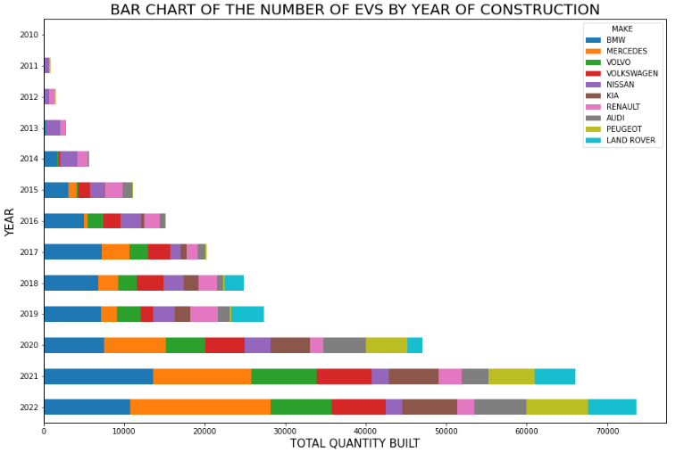

GitHub folder link: <https://github.com/varunraaju/Battery_Cycle_Plots/tree/a3ccf2c92e5eddc0972bd76c2c28c0eec426fb29/3_2>

* 1. Predicted Number of EVs by Year of Construction and Battery Health

Type of visualizations: Multiple Line graph

Description: The X-axis represents the forecasted years from the forecasted data and Y-axis represents the number of EV’s. The different lines represent the state of health of the battery.

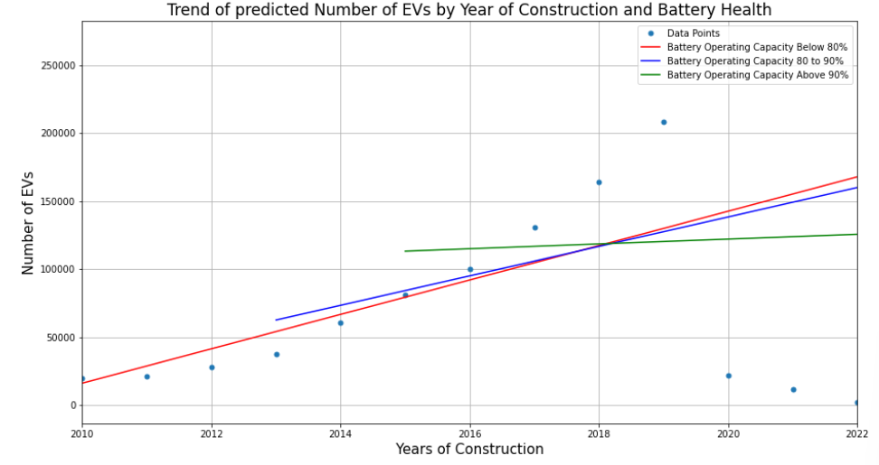

GitHub folder link: <https://github.com/varunraaju/Battery_Cycle_Plots/tree/a3ccf2c92e5eddc0972bd76c2c28c0eec426fb29/3_3>

* 1. Trend of predicted Number of EVs by Year of Construction and Battery Health

Type of visualizations: Multiple Line graph

Description: The X-axis represents the forecasted years from the forecasted data and Y-axis represents the number of EV’s. The different lines represent the state of health of the battery.

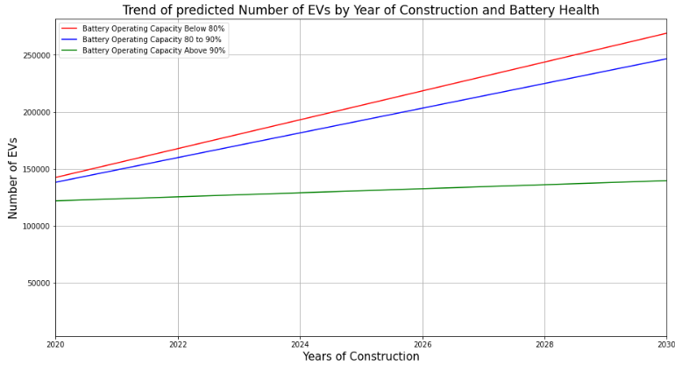

GitHub folder link: <https://github.com/varunraaju/Battery_Cycle_Plots/tree/fb4d7c4fef174926b30aa3f6575695f30d2e2656/3_4>

* 1. Predicted Age and Mileage Distribution b Model and Battery Health

Type of visualizations: Gridded bubble chart

Description: The Y-axis represents the battery health of the EVs, and X-axis represents the EV models. The values being used to populate the bubbles are the number of EVs by mileage and battery health.

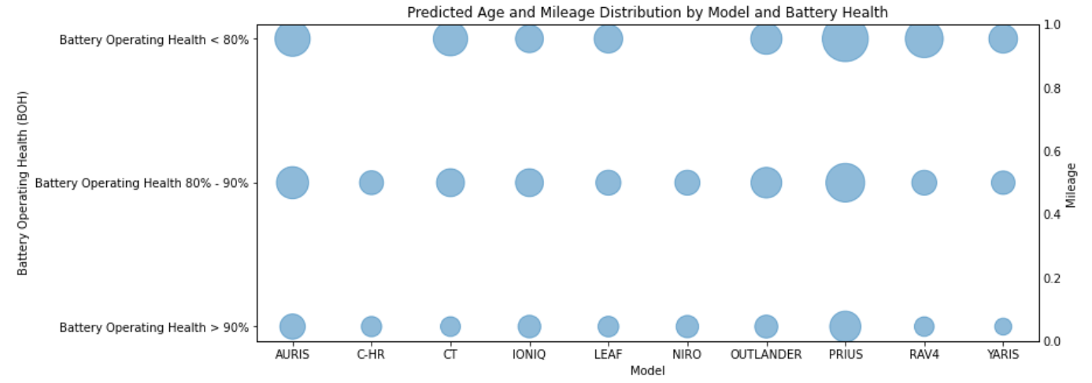

GitHub folder link: <https://github.com/varunraaju/Battery_Cycle_Plots/tree/fb4d7c4fef174926b30aa3f6575695f30d2e2656/3_5>

## Forecast:

The Forecast section will have the following sections in it:

* 1. Predicted Number of EV Dismantled per year up to 2035 by Maker

Type of visualizations: Multiple line graph

Description: The X-axis represents the forecasted years from the forecasted data and Y-axis represents the number of EV’s. The different lines represent the different makes of the EVs.

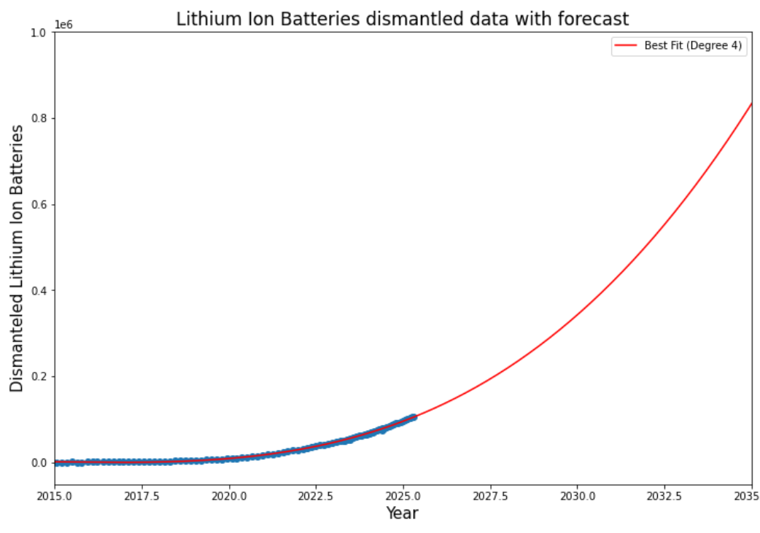

GitHub folder link: <https://github.com/varunraaju/Battery_Cycle_Plots/tree/fb4d7c4fef174926b30aa3f6575695f30d2e2656/4_1>

* 1. Predicted Proportion of EVs by Body Type (2025-2030)

Type of visualizations: Vertical stacked bar graph

Description: The X-axis represents the forecasted years from the forecasted data and Y-axis represents the proportion of EV’s. The different stacks represent the different type of EVs.

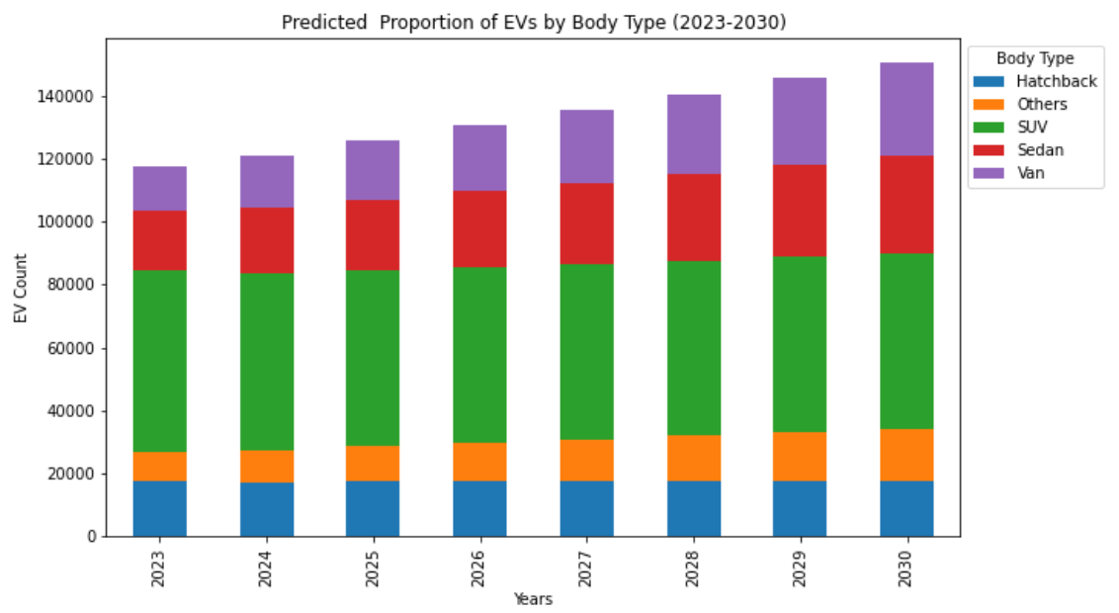

GitHub folder link: <https://github.com/varunraaju/Battery_Cycle_Plots/tree/fb4d7c4fef174926b30aa3f6575695f30d2e2656/4_2>

* 1. Predicted Mileage Distribution by Make and Age

Type of visualizations: The x-axis represents the make of the EVs and the y-axis represents the mileage of the EVs. The different stacks on the bar represent the age of the EVs.

Description:

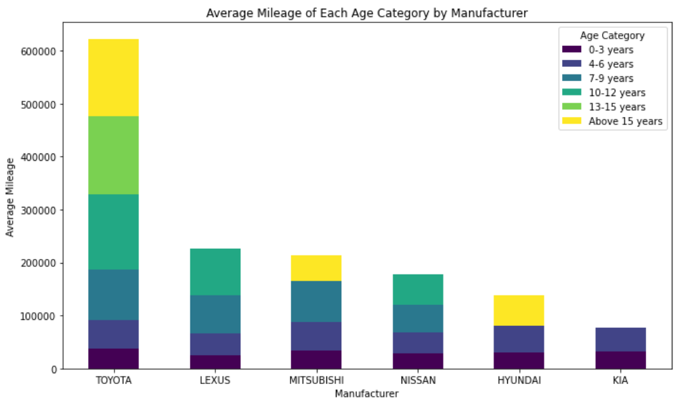

GitHub folder link: <https://github.com/varunraaju/Battery_Cycle_Plots/tree/66da51269790db09694a3c452712adba1142fe13/4_3>

* 1. Total Actual Battery Capacity by EV Model and Car Maker in the UK (2020)

Type of visualizations: Vertical Stacked Bar chart

Description: The x-axis represents the different EV models and y-axis represents the battery capacity of the EVs. The different stacks on the bars represent different makes of the EVs.

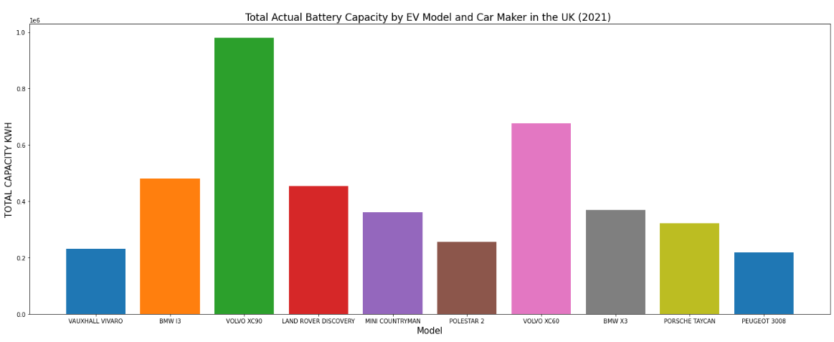

GitHub folder link: <https://github.com/varunraaju/Battery_Cycle_Plots/tree/fb4d7c4fef174926b30aa3f6575695f30d2e2656/4_4>

* 1. EV Battery Raw Materials

Type of visualizations: Clustered bar chart

Description: This clustered bar chart has tons of material used on the Y-axis and the X-axis has the different materials used in battery manufacturing. The different bars in the clusters represent the last 3 years in the data.

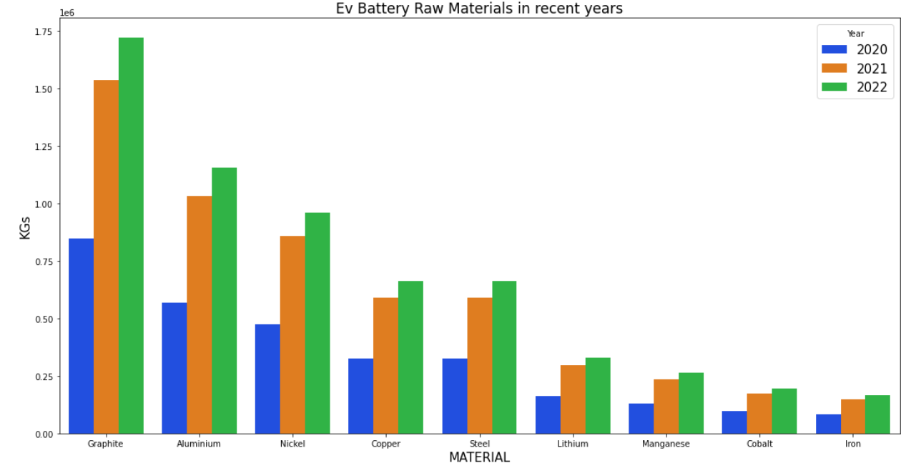

GitHub folder link: <https://github.com/varunraaju/Battery_Cycle_Plots/tree/fb4d7c4fef174926b30aa3f6575695f30d2e2656/4_5>

## EV Battery Parc:

The EV Battery Parc section will have the following sections in it:

* 1. Total Number of EVs by Make over Time in the UK

Type of visualizations: Multiple line graph

Description: The X-axis represents the years from the data and Y-axis represents the number of EV’s. The different lines represent the different makes of the EVs.

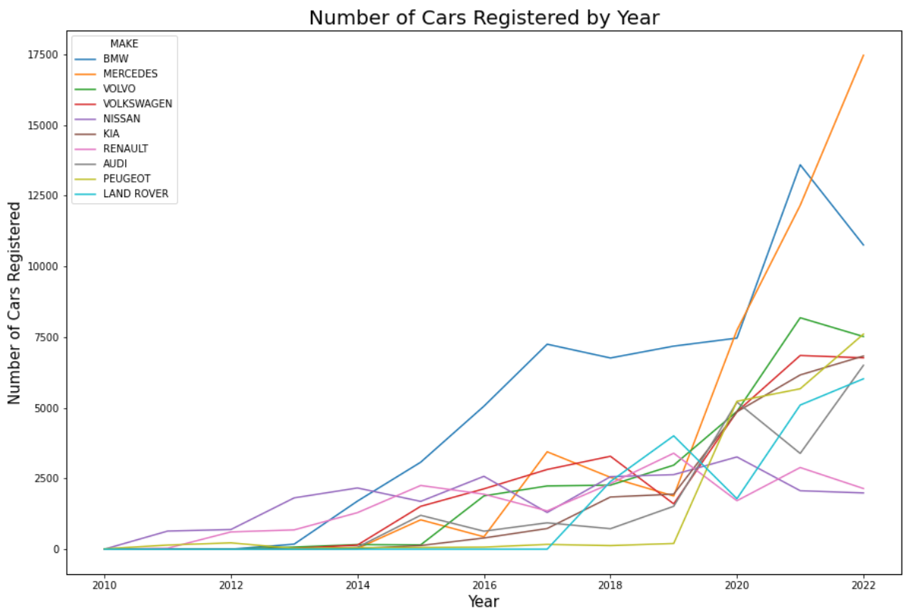

GitHub folder link: <https://github.com/varunraaju/Battery_Cycle_Plots/tree/fb4d7c4fef174926b30aa3f6575695f30d2e2656/5_1>

* 1. Proportion of EVs by Body Type in the UK (Last 5 years)

Type of visualizations: Clustered bar graph

Description: The X-axis represents the last 5 years from the data and Y-axis represents the proportion of EV’s. The different bars in the clusters represent the different types of EVs.

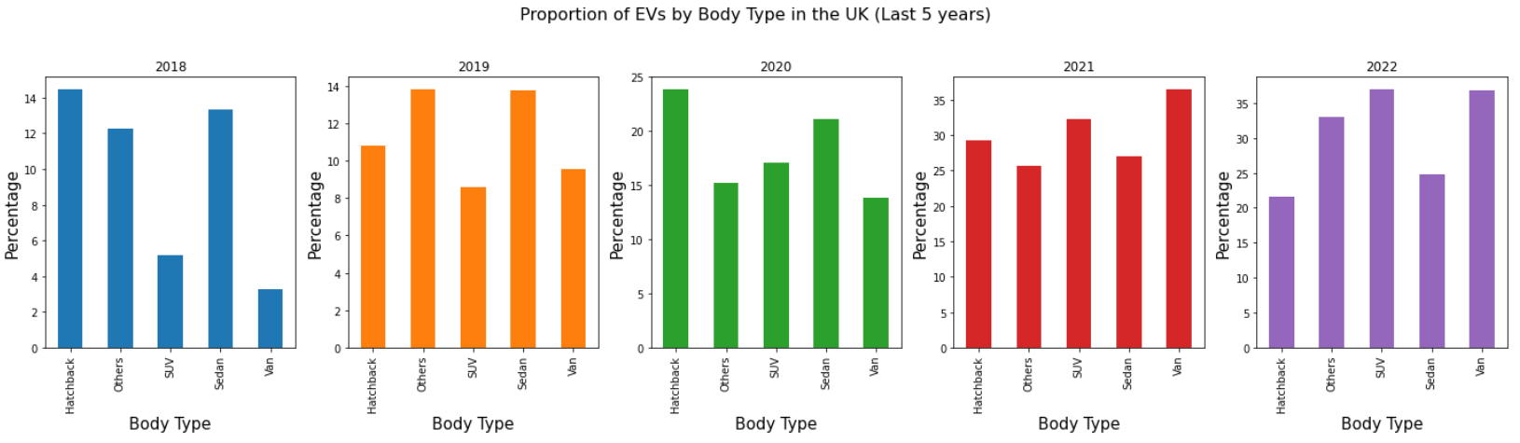

GitHub folder link: <https://github.com/varunraaju/Battery_Cycle_Plots/tree/fb4d7c4fef174926b30aa3f6575695f30d2e2656/5_2>

* 1. Total Actual Battery Capacity by EV Model and Car Maker in the UK (2021)

Type of visualizations: Vertical stacked bar graph

Description: The x-axis represents the different EV models and y-axis represents the battery capacity of the EVs. The different stacks on the bars represent different makes of EVs. This data is visualized only for the year 2021.

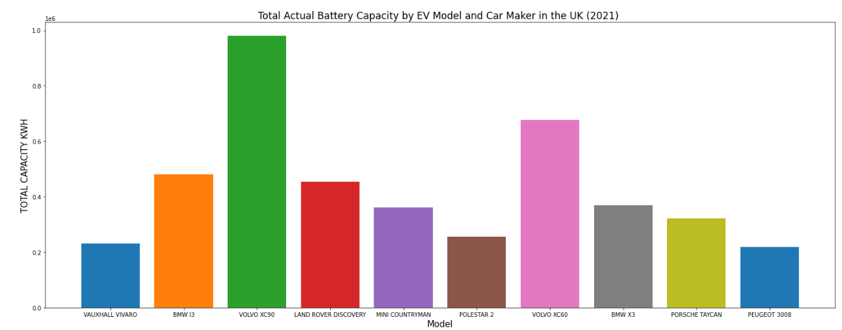

GitHub folder link: <https://github.com/varunraaju/Battery_Cycle_Plots/tree/fb4d7c4fef174926b30aa3f6575695f30d2e2656/5_3>

* 1. Battery Component Weights by OEM

Type of visualizations: Vertical stacked bar graph

Description: The y-axis represents the weight of different materials and the x-axis represents the different makes of EVs. The different stacks on the bars represent the different materials used for making EVs.

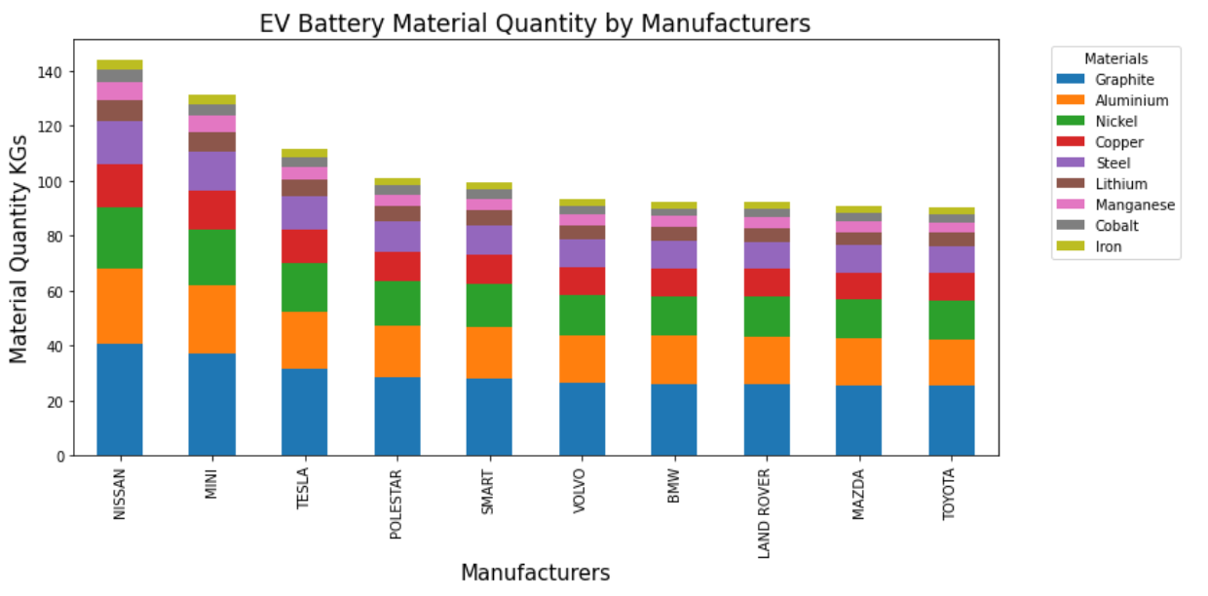

GitHub folder link: <https://github.com/varunraaju/Battery_Cycle_Plots/tree/fb4d7c4fef174926b30aa3f6575695f30d2e2656/5_4>

# Data Source:

The data source is going to be an Excel file, which will consist of multiple sheets.

1. **“Beyond the EVent horizon: Battery waste, recycling, and sustainability in the United Kingdom electric vehicle transition”** article for EV Battery EOL data (Fig 5). Skeete, J.-P., Wells, P., Dong, X., Heidrich, O. and Harper, G. (2020). Beyond the EVent horizon: Battery waste, recycling, and sustainability in the United Kingdom electric vehicle transition. Energy Research & Social Science, 69(1), p.101581. doi:https://doi.org/10.1016/j.erss.2020.101581.
2. **“Anonymised MOT tests and results”** data from UK Government website. Department for Transport (2022). *Anonymised MOT tests and results*. [online] www.data.gov.uk. Available at: <https://www.data.gov.uk/dataset/e3939ef8-30c7-4ca8-9c7c-ad9475cc9b2f/anonymised-mot-tests-and-results>.
3. **“Vehicle licensing statistics: 2022”** from UK Government website. GOV.UK. (n.d.). *Vehicle licensing statistics: 2022*. [online] Available at: <https://www.gov.uk/government/statistics/vehicle-licensing-statistics-2022>.
4. Manual search data for battery capacity and body type.

# Dashboard Access:

Links of the respective GitHub repository folders has been provided below the reference plots. Access will be shared during the project initiation.

# Data Dictionary:

|  |  |  |
| --- | --- | --- |
| **Field** | **Data Type** | **Description** |
| Geography | String | Location of the EV |
| Units | String |  |
| BodyType | String | Type of automobile |
| Make | String | Company manufacturing EV |
| Generic model | String | Name of the model of the EV |
| Capacity(kWh) | Decimal | The specified capacity of the EV |
| Total_capacity(kWh) | Decimal | The actual capacity of the EV in kWh unit |
| Total_capacity(mWh) | Decimal | The actual capacity of the EV in mWh unit |
| Minerals (Kgs) | Decimal | Total weight of all minerals in EV |
| Graphite | Decimal | Weight of graphite in EV |
| aluminum | Decimal | Weight of aluminum in EV |
| nickel | Decimal | Weight of nickel in EV |
| copper | Decimal | Weight of copper in EV |
| Steel | Decimal | Weight of steel in EV |
| manganese | Decimal | Weight of manganese in EV |
| cobalt | Decimal | Weight of cobalt in EV |
| lithium | Decimal | Weight of lithium in EV |
| iron | Decimal | Weight of iron in EV |
| Fuel | String | Type of fuel being used in the EV |
| 2022 Q3 | Integer | The number of Evs across different quarters |
| 2022 Q22 | Integer |
| 2022 Q1 | Integer |
| 2021 Q4 | Integer |
| 2021 Q3 | Integer |
| 2021 Q2 | Integer |
| 2021 Q1 | Integer |
| 2020 Q4 | Integer |
| 2020 Q3 | Integer |
| 2020 Q2 | Integer |
| 2020 Q1 | Integer |
| 2019 Q4 | Integer |
| 2019 Q3 | Integer |
| 2019 Q2 | Integer |
| 2019 Q1 | Integer |
| 2018 Q4 | Integer |
| 2018 Q3 | Integer |
| 2018 Q2 | Integer |
| 2018 Q1 | Integer |
| 2017 Q4 | Integer |
| 2017 Q3 | Integer |
| 2017 Q2 | Integer |
| 2017 Q1 | Integer |
| 2016 Q4 | Integer |
| 2016 Q3 | Integer |
| 2016 Q2 | Integer |
| 2016 Q1 | Integer |
| 2015 Q4 | Integer |
| 2015 Q3 | Integer |
| 2015 Q2 | Integer |
| 2015 Q1 | Integer |
| 2014 Q4 | Integer |
| 2014 Q3 | Integer |
| 2014 Q2 | Integer |
| 2014 Q1 | Integer |
| 2013 Q4 | Integer |
| 2013 Q3 | Integer |
| 2013 Q2 | Integer |
| 2013 Q1 | Integer |
| 2012 Q4 | Integer |
| 2012 Q3 | Integer |
| 2012 Q2 | Integer |
| 2012 Q1 | Integer |
| 2011 Q4 | Integer |
| 2011 Q3 | Integer |
| 2011 Q2 | Integer |
| 2011 Q1 | Integer |
| 2010 Q4 | Integer |
| 2010 Q3 | Integer |
| 2010 Q2 | Integer |
| 2010 Q1 | Integer |